Working copy of APES Review Sheet
V. Environmental Quality
1. Air pollution
sulfur dioxide- comes from burning fossil fuels with high sulfur content, is an important precursor to acid rain
carbon monoxide- has a stronger affinity for hemoglobin than oxygen has
radon- comes from rocks below house foundations and has been implicated as the cause of as much as 15 percent of lung cancer cases.
Methane- a greenhouse gas, that is flammable and produced by landfills
carbon dioxide- the major contributor to greenhouse effect, regulated by the Kyoto conference
ozone- stratospheric importance in protecting us from UV radiation. Destroyed by chlorofluorocarbons. Causes lung damage and damage to plant tissue in the troposphere. It is formed by photochemical reactions
CFC's- chlorofluorocarbons give off a chlorine in the stratosphere and the Cl attaches to free oxygen to deplete the ozone layer
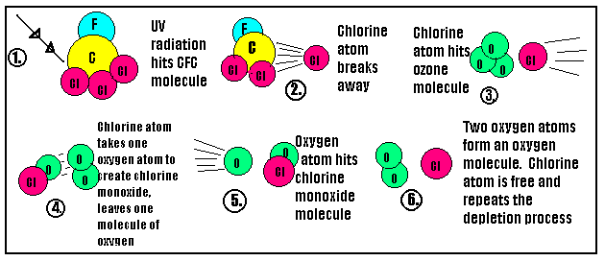
Main environmental effects of ozone depletion are:
lower food-crop production
disruption of marine food chains
increased incidence of skin cancer
reduction of primary productivity in the ocean

Global Warming
Greenhouse gases- methane(CH₄), CFC's, carbon dioxide, Nitrous oxide(NO_{X}, N₂O)
Most data indicate that the mean global annual temperature has increased by .5 degrees C
In the models of global warming, the most important factor contributing to an increase in sea level is the thermal expansion of the oceans
Effects of global warming are:
loss of fertile delta regions for agriculture
change in global patterns of precipitation
extinction of some species that have narrow temperature requirements
increased frequencies of hurricanes
Location where the greatest number of people would be directly affected by global warming-coastlines, esp. under sea level and small islands.
Greenhouse gases include carbon dioxide, methane, ozone, nitrous oxides, CFC's
The greenhouse effect- infrared radiation from the earth's surface is absorbed by gases in the atmosphere.
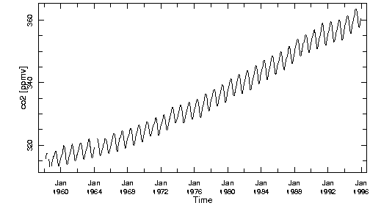
The graph above shows how carbon dioxide levels have increased since 1956. The increased consumption of fossil fuel seem to contribute to the increase in the amount of Carbon Dioxide in the atmosphere. The yearly fluctuations in the curve indicate seasonal fluctuations in photosynthetic activity.
Technology advances that have reduced particulates
bag filters
electrostatic precipitators

Environmental effects of Acid rain
acidification of lakes and soils
erosion of limestone structure,
damage to plant foliage,
respiratory irritation
Rising number of cars have lead to increases in NO_{X} formation
Catalytic converters do remove NO_{X}'s and remove CO
Sources of sulfur dioxides:
coal burning power plants
industrial processes that burn coal and oil
Reactions
2SO₂ + O₂ ----------->2SO₃
SO₃ + H₂0 ---------->H₂SO₄
H₂SO₄ + 2H₂0-------> 2H₃0⁺ + SO₄⁻²
Remediation and reduction
add lime to acidified lakes
reduce fossil fuel use
burn lower sulfur fuel
install air pollution devise electrostatic precipitator or flue gas desulfurization (scrubbers)
develop alternative energy sources
burn coal more cleanly and efficiently using fluidized bed combustion
Sources of Nitrous Oxides
automobile exhaust
stationary sources of fuel combustion
Oxides of nitrogen include
NO, NO₂, N₂O
HNO₃ +H₂0---------> H₃O⁺ + NO₃⁻
Reduction and remediation methods include
reduction in the use of motor vehicles
increase in the efficiency of motor vehicles
install catalytic converter
reduce use of nitrogen fertilizer
use alternative energy sources
burn coal more cleanly and efficiently using fluidized bed combustion
add lime to acidified lakes
Carbon Monoxides
carbon monoxide reduction technology include catalytic converters
oxygenating fuel additives
carbon monoxide reduces the blood's ability to transport oxygen to tissues
Chemical, Physiological and Ecological factors that are altered by acid rain in and around aquatic habitats
Heavy or toxic metals such as Al, Pb, Cd, Cu, Fe are released into solution at lower pH levels
chemical elements are dissolved and kept in solution at lower pH and leave the lake via outflows.
Increased nitrogen levels from nitric acid stimulate plant growth resulting in an algal bloom and depletion of other soil nutrients
Increased nitrogen levels from nitric acid stimulate plant growth resulting in an algal bloom and a decrease in DO levels to a point out of the range of tolerance
increased death and decomposition result in lower DO levels
reduced photosynthesis leads to reduced DO levels
reproduction rates are reduced
disruption of the food web results from the decline or loss of pH sensitive organisms at various trophic levels
survival of eggs, young, fry or fingerlings is reduced
interferes with respiration, damages gills, and prevents oxygen uptake
causes bone decalcification
disrupts muscle contraction
interferes with enzyme activity
causes tissue damage
Causes of lake acidification
sulfur dioxide in the atmosphere reacts with atmospheric gases to produce sulfuric acid
NO_{X} in atmosphere react with atmospheric gases to produce nitric acid
sulfuric acid and toxic metals leach from mines
Hydrochloric acid and sulfuric acid industrial wastes are discharged into the watershed
organic acids enter the lake as a result of the logging process
organic acids and metallic cations in leachate flow into the lake from leaking sanitary landfills
Chemicals such as DDT and PCB's that are used in one region of the Earth can circulate in the biosphere and affect organisms in a distant region

El Nino La Nina
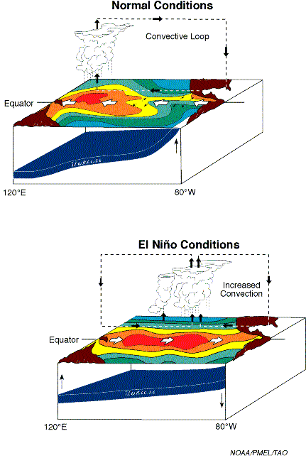
2. Toxic metal pollutants
cadmium- heavy metal that is toxic found in incinerator ash, released when coal is burned
chromium- toxic heavy metal
lead- toxic metal pollutant that is a neurotoxin that comes from air pollution from burning of leaded gasoline or indoors from lead based paints
mercury- toxic metal pollutant that is a neurotoxin
3.Acid deposition can be reduced by reducing the use of fossil fuels
Heavy metals in the municipal sewage sludge would be the strongest reason not to use it as a fertilizer
B. Solid Waste Treatment
Sanitary landfill- this method is used most frequently to get rid of solid waste in the US today. In a sanitary landfill, trash and garbage are crushed and covered each day to prevent accumulation of vermin and spread of disease The greatest problem associated with sanitary landfills is leachate contamination of groundwater
incineration- this method of solid waste disposal reduces the volume of waste but could release toxic emissions into the atmosphere
discharge to sewers, streams and rivers- in this case you are hoping that dilution is the solution. Not a very effective way of getting rid of solid waste.
chemical treatment- this method is best suited for neutralizing the acidic component of waste
biological treatment- introduces microorganisms to breakdown hazardous organic compounds. Bioremediation is the reconstruction of an ecological area with the aid of living organisms. Most of these are microbes. An example of environmental remediation would be spraying PCB consuming bacteria on an area that has soil contaminated with PCB's.
Solid waste management
methods in terms of least energy used to most energy used
reduce------------>reuse-------------------> recycle
The single largest component of municipal solid waste is paper
II. Interdependence of Earth's Systems
A. Kinetic energy- matter in motion has energy
heat flow- energy is transferred from one object to another as the result of a temperature difference
First Law of thermodynamics- the amount of energy in an isolated system stays constant
Second law of Thermodynamics- an energy transformation occurs and results in increased disorder
C. The Solid Earth
The element that constitutes the highest percentage of mass in the Earth's crust is oxygen
The element that constitutes the second highest percentage of mass in the Earth's crust is silicon.
The most common element in the entire solid earth is iron
the second most common is oxygen
Major reserve of nitrogen on this planet is N₂ found in the atmosphere
The major reserve of sulfur is in the rocks in the lithosphere
Most volcanism is associated with plate boundaries
Approximately 2.5% of the water on Earth is freshwater (liquid or solid)
D. The Atmosphere
The most abundant gas in the earths atmosphere is N₂
E. Biosphere
Trophic levels of organisms-producers lowest, herbivores (primary consumers), carnivores( secondary consumers)
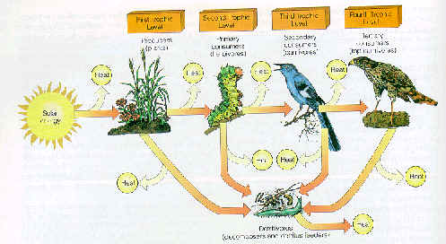
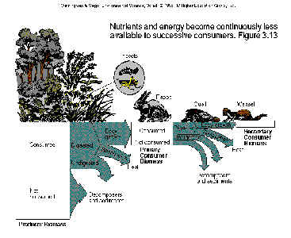
Be able to relate these diagrams to the advantages of eating a vegetarian type of diet.
Habitat fragmentation- creates small islands of habitat this reduces species diversity, increases the amount of edge habitat, decreases gene flow within species, usually leads to a decrease in the numbers of top carnivores in the population
Organisms have adaptations to acquire energy from their external environment such as dark, heat absorbing coloration and fangs and claws

Biomes
Tundra
Antarctic environment is very fragile and extremely vulnerable to the disturbances that would accompany development in this biome
Tropical Rain Forest
biome with the most biodiversity. Soils do not have many nutrients in them the majority of the nutrients are tied up in the canopy. If the rainforest is removed the soils are depleted of nutrients quickly
Location where there is the greatest biodiversity. remaining- Tropical rainforests of South America.
When you lose diversity, there is an increased susceptibility to plant diseases
Desert
most of the earth's deserts are approximately 30º latitude north and south because these latitudes are characterized by descending dry air currents
Desertification is occurring most rapidly along the fringes of the Sahara Desert in Africa since nomadic people who aren't using the land wisely are depleting the soils and turning it into desert
Symbiotic relationships
commensalism- + 0 like moss growing on a tree
parasitism- + - ticks feeding on a deer
mutualism- + + bees and flowers
predation- lion eating an antelope on the savannah
competition- starling displacing bluebirds
Evolution is indicated by a population changing not an individual. A good example of the process of evolution would be a population of mosquitoes developing resistance to a pesticide, or a population of microbes developing resistance to a particular antibiotic.
II B. Cycling of Matter
Important inorganic compounds include water and salts

Biogeochemical cycles
Carbon Cycle
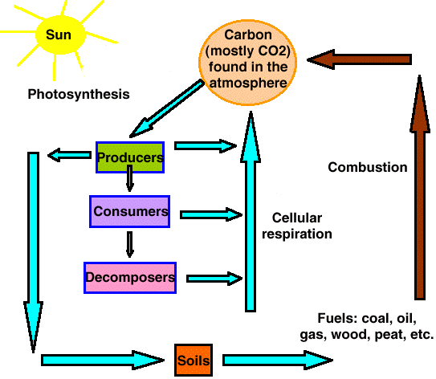
The two major processes involved in the carbon cycle are photosynthesis and respiration
Nitrogen cycle
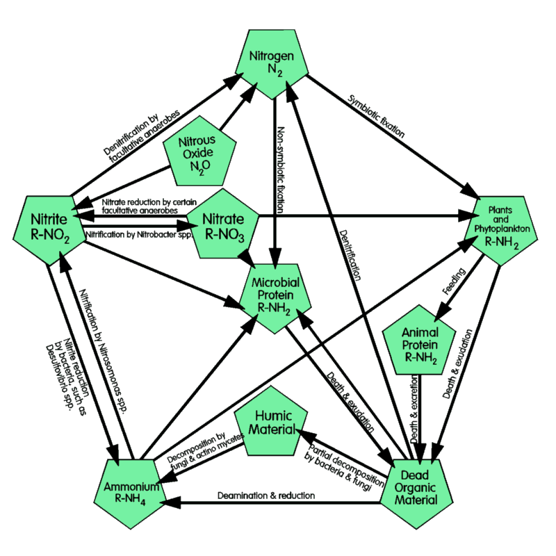
Sulfur cycle
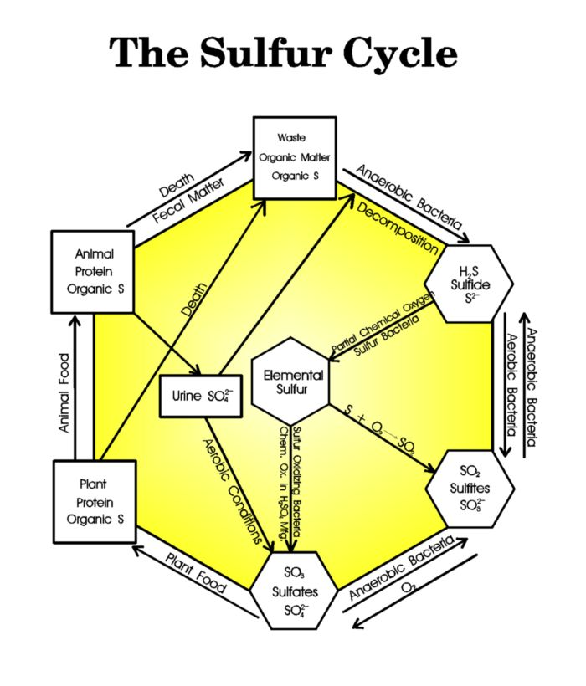
Phosphorous Cycle
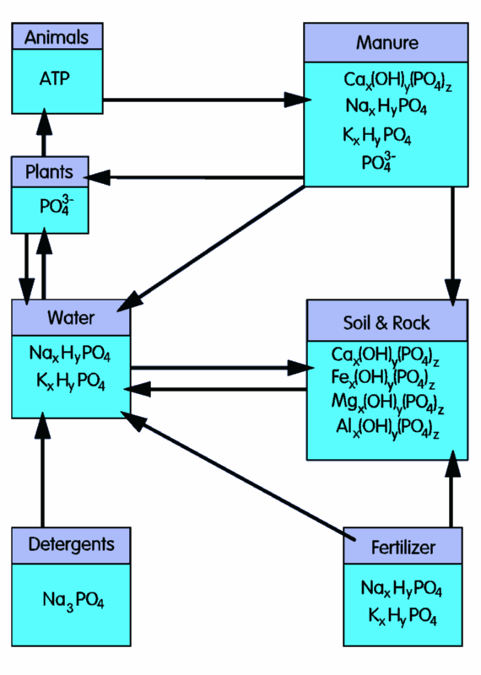
Both carbon and sulfur have a gaseous stage at some point in their cycle. Phosphorous does not.

II C. The geologic time scale
Earth is considered a little over 5 billion years old.
Precambrian era lasted until about 570 million years ago very little fossil evidence.
Paleozoic era goes from approx 570 million to 225 million years ago. This era includes the carboniferous period when the great coal deposits were laid down
Mesozoic era goes from approx.225 to 65 million years ago and includes the Triassic, Jurassic and Cretaceous periods This is when the dinosaurs were present on this planet.
We now live in the Cenozoic era which began 65 million years ago to today. High rates of human extinction occurred in this era. Man has been around maybe 1.6 million years.
IV.
A
1. Water quality
Acidity- measured on the pH scale, pH of 4 has 1X10⁻⁴ hydrogen ion concentration
turbidity- caused by suspended particles
dissolved oxygen- decreased by the breakdown of organic waste, the major source of dissolved oxygen in the ocean comes from photosynthesis by phytoplankton
hardness- measured by amount of Ca⁺² and Mg⁺²
salinity- amount of dissolved salts especially sodium chloride in a given volume of water
High levels of fecal coliform bacteria in a water source indicates that the water has been contaminated by untreated human or animal waste
Eutrophication in lakes and streams is accelerated with nitrates and phosphates
When a pesticide is not metabolized or excreted by an organism, it gets stored in fatty tissue. Over time the organism may accumulate high concentrations of the pesticide. The buildup of such a pesticide in an organisms body is known as bioaccumulation
Organisms at higher levels on food webs tend to have greater concentrations of bioaccumulated pesticide stored in their bodies than those lower on food webs. The increase in pesticide concentrations as the pesticide passes through successive levels of the food web is known as biological magnification
Integrated pest management combines biological cultural and chemical controls that are tailored to the conditions and crops of the individual farm
The greatest amount of water for domestic use in the US is used flushing the toilet
The greatest amount of water in the world is used in agricultural processes
Dissolved oxygen goes down after a point source of pollution is added to a stream or lake.
Point sources of pollution would be pollution that enters a water source from a particular place like a pipe that comes from a factory, dairy, etc.
Non Point sources of pollution would include: storm water, acid precipitation, agricultural runoff, residual pesticide runoff
Know this diagram
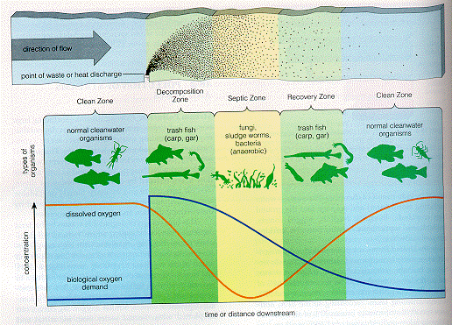

C. Soils
Sand has the greatest permeability
Clay has the least permeability
The best way to remediate soil salinization is to add large amounts of water to leach out the salts.
Overgrazing of public land by privately owned livestock is an example of "tragedy of the commons" which was an essay written by Garret Hardin about the abuse of our commons which could be public lands or waters.
Swapping debt for nature is the concept that foreign lands are forgiving for their debt if they agree to protect land from development.
E. Energy sources
Coal- largest coal reserves are in China
Most coal laid down in the Carboniferous period( 285-360 million years ago)
nonrenewable resource
At present rates of consumption we have about 200 years of coal left
Mining
underground dangers of cave ins fires accidents accumulation of methane carbon monoxide, many miners died of black lung disease.
strip mining is cheaper but environmental costs are higher. Water pollution including sulfur compounds come out of tailings and can be very toxic.
air pollution
burning coal releases radioactivity and many toxic metals including lead and mercury. You are likely to be exposed to more radioactivity near a plant that burns coal than a nuclear power plant
coal contains up to 10% sulfur by weight. can remove by flue gas scrubbing. If not removed released in atmosphere to produce sulfuric acid and acid rain. Burning coal also oxidize nitrogen compounds to NO_{X}
We produce 1 trillion tons of carbon dioxide annually burning coal.
Oil
Petroleum deposit will have varying mixtures of oil, gas and solid tar-like materials. A lot of time oil and gas deposits are found under impermeable shale layers.
An oil well is not an oil pool in a reservoir of liquid in an open cavern but rather individual droplets or a thin film of liquid permeating spaces in a porous sandstone or limestone.
We normally only remove 30-40% of the oil in an oil well. There are ways to force the oil out. You can force steam or water into a well but at least 1/2 of the total deposit remains in the ground.. Methods to remove more oil from a well are called secondary recovery techniques.
At current consumption rates we have about 50 years of oil left. This does not take into account the oil in shale and tar sands Oil shale is a sedimentary rock called kerogen which when heated to 900 degrees F oil will come out of the rock. To get oil out of both of these sources it uses a tremendous amount of water and has a high potential for air and water pollution.
The United States has a great potential for discovering oil on the California Coast, the Beaufort Sea and in Alaska. Because of the damage that was caused by the Exxon Valdez people do not think it is worth the social and environmental costs
Natural Gas
Third largest commercial fuel. Natural gas produces only half as much carbon dioxide as an equivalent amount of coal and substitution could help reduce global warming. We have about 60 years of it left at present consumption rates.

Nuclear Power Plant
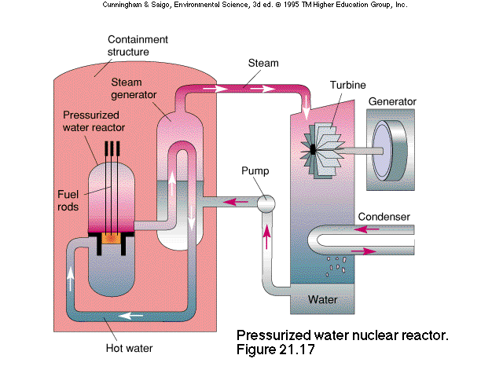
A= core, fuel rods, reactor, control rods, moderator
function- nuclear reaction site, fission
B= containment, reactor building
function- protective, prevent radiation leakage
C= heat exchanger, steam pipes
function- heat transfer
D= turbine, turbo-generator
function-drives generator, kinetic to mechanical E
E= generator, transformer
function-produces electricity, mechanical to electrical E
F= cooling tower
function-cools or recycles the H2O, releases waste heat to atmosphere.
Don't confuse fission with fusion. All nuclear power plants in the US use nuclear fission reactions. This means that large atoms are each split into two smaller atoms with the release of large amounts of energy.
Nuclear fusion is a reaction in which two smaller atoms are combined to make one larger atom with the release of large amounts of energy
Environmental problems associated with nuclear power plant
meltdown- caused by loss of coolant or fuel rod exposure- the radiation release effects mutations, increase in cancer and death, decrease population, reduced growth rate, fertility rate
wastes and used fuels produced- how do you store dispose and transport
thermal pollution generated from cooling
leaks releases of radiation to environment
fuel processing-mining, production enrichment
decommissioning-storage disposal and transport of facility
water use-volume used, intake/output
High level nuclear waste is stored right at the reactor site
the ultimate source of energy for terrestrial ecosystems is the SUN
Uranium is considered a nonrenewable energy resource
nuclear fission - this source produces long-lived hazardous wastes and is nonrenewable
Problem: If something has a half-life of 10 years and an activity level of 2 curies. After how many years will the activity level be .5 curies? 20 years
sunlight- the source that is converted directly into electrical energy by photovoltaic cells.
Biomass- the source whose use is a direct cause of deforestation
Steps in the formation of coal
dead plant matter, peat, lignite, bituminous coal (soft coal with a lot of sulfur), anthracite coal (less sulfur and harder)
Oil is a nonrenewable resource . All of the following substances are derived form oil, asphalt, DDT, polystyrene, nylon
Energy Problem- If an incandescent light bulb has an efficiency rating of 5 %, then for every one joule of electrical energy consumed by the bulb, how much light energy is produced? Answer .05 joules of light energy. How much heat energy .95joules.
F. Land
Clear cutting forests will result in topsoil depth decrease, water temperature in streams running through the region will increase, volume of streams after rainfall will increase, the frequency of landslides will increase
Floodplains are important to humans historically because they are fertile, are flat and are close to rivers for transportation
Artificial levees and embankments will increase the amounts of sediments deposited at the mouth of the river system.
National Parks- oldest Yellowstone, next Yosemite. these area have multiple roles from providing biological habitat to facilitating human recreation. Roads and buildings can be constructed in these areas.
National wildlife refuges- preserves lands and waters for the conservation of fishes, wildlife and plants of the United States. Hunting, fishing and photography are permitted on these lands. Roads are built in these refuges
National Forests-these areas have multiple uses including timber harvest, livestock forage, water resource management, mining, recreation, and habitat for fish and wildlife.
National wilderness preservation areas- only one of the areas described here where road construction, logging, and mining are banned

VII. Laws and Regulations
National Environmental Policy Act( NEPA) of 1969 requires all agencies responsible for a major federal project to file an environmental impact statement-The best way the protect endangered and threatened species is by protecting the habitat.
Endangered Species Act of 1973 (ESA) seeks to identify all endangered species and populations and to save as much biodiversity. as possible regardless of its usefulness to humans.
Delaney Clause-an amendment to the federal food, drug and cosmetic act added in 1058 prohibiting the addition of any known cancer causing agents to processed foods drugs or cosmetics.
Safe Drinking Water Act(1974)- requires minimum safety standards for every community water supply.. Contaminants regulated are bacteria, nitrates, arsenic, barium, cadmium, chromium, fluoride, lead, mercury, silver, pesticides
Clean Water Act(1985)- set as a national goal the attainment of fishable and swimable surface waters in the United States. The law says that there will be no net loss of wetlands
Migratory Bird Treaty Act- this act prevents the destruction of the habitat of non-game migratory bird species
Clean Air Act(1970) mandated the phasing out of open burning thereby reducing the emission of particulates
CITES Treaty- has been helpful in protecting endangered animals and plants by listing those species and products whose international trade is controlled
Wilderness Act- any land designated as wilderness is to remain road less and free of development
Environmental Disasters
Bhopal India- a poison gas escaped from Union Carbides pesticide plant killing 1754 and injuring 200,000
Minamata, Japan- mercury contaminated seafood poisoned many in this town. This type of mercury poisoning is called minamata disease,
Love Canal, New York- toxic chemical stored underground leaked into municipal water supply causing cancer in many and eventually lead to the evacuation of town
Chernobyl, Ukraine - meltdown of nuclear power plant
Three Mile Island, Pennsylvania- partial meltdown of reactor core in 1979 . Most of the radioactive material was kept inside the containment building.
III. Population dynamics
Stabilization or reduction of the size of the human population would have the greatest positive impact on the quality of the natural environment
Be able to interpret various graphs and tables
exponential growth- growth at a constant rate of increase per unit of time
carrying capacity -the maximum population a specified environment can support over a prolonged period without degrading the environment.
Environmental resistance- factors that tend to reduce population growth rates
70/rate of population growth = doubling time
J curve
S curve
biotic potential-maximum reproductive rate of an organism
dieback- population crash

Be able to read graph above
Zero population growth is found when birth rate and death rate are =
The steeper the slope of the line the greater the rate of births or deaths over time
Human Population is most stable in Japan , the US and some of the European countries
The population size of an exotic species often grows rapidly when the species is introduced in a new environment include
there is a large underutilized food source in the new environment
the exotic species has few natural predators in the new environment
Be able to read age structure histograms as illustrated below
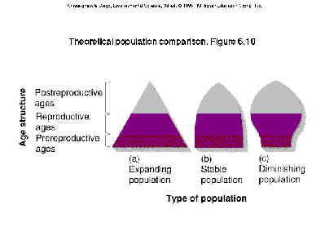
People living in developing countries eat much less beef than people in developed countries
People in highly developed countries utilize:
86% of aluminum used
76%of timber harvested
68%of energy produced
61% of the meat eaten
42% of the fresh water consumed
Rich nations also generate 75% of the world's pollution and waste

VI. Global Changes and their consequences.
A. First order effects
By destroying wetlands surrounding a river you
increase the sediment load in the river
increase pollutants such as nitrates in the river
decrease the diversity of aquatic species
Decrease the level of oxygen in the river since the won' t have cover and the temperature of the water will increase
An increase in the frequency of flooding in the river
Vocabulary
Abiotic- nonliving
acid- releases hydrogen ions in solution
acid deposition-a type of air pollution that includes acid that falls form the atmosphere to the Earth as precipitation or dry acidic particles
adaptive radiation- the evolution of a large number of related species from an unspecialized ancestral organism
aerosol- tiny particles of natural and human-produced air pollution that are so small they remain suspended in the atmosphere for days or even weeks
aerosol effect- atmospheric pollution that occurs as a result of aerosol pollution
agroforestry- forestry and agricultural techniques that are used to improve degraded areas
A-horizon- the topsoil; located just beneath the O horizon of the soil.
allelopathy- an adaptation in which toxic substances secreted by roots or shed leaves inhibit the establishment of competing plants.
ammonification- the conversion of nitrogen containing organic compounds to ammonia by certain ammonifiying bacteria in the soil
anthracite- the highest grade of coal. has the highest heat content and burns the cleanest of any grade of coal
aquaculture-the rearing of aquatic organisms either freshwater or marine for human consumption
aquifer-underground caverns and porous layers of underground rock in which groundwater is stored.
artificial eutrophication- overnourishment of an aquatic ecosystem by nutrients such as nitrates and phosphates. The pace of eutrophication is usually accelerated due to human activities such as agriculture and discharge from sewage treatment.
barrier island- low narrow sandy islands that form offshore from a coastline.
Batseian micmicry- evolution of one species to resemble the coloration, body shape or behavior of another species that is protected form predators by venom, bad taste, or some other defensive mechanism
benthos- the bottom of the sea or lake
Best available technology(BAT) the best pollution control available
beta particles- high energy electrons released by radioactive decay
bioaccumulation-the selective absorption and concentration of molecules by a cell
biocide- a broad spectrum poison that kills a wide range of organisms
Review Session 1
definition of environmental science
Human numbers
endocrine disruptors -PCB's, polycarbonates, heavy metals
antagonism, synergism
commercial extinction
as technology advances so does the impact we have on the environment
Declining bird populations
neotropical birds
forest edge
nest or brood parasitism
forest fragmentation
Introduction of Exotic species
as we become more mobile foreign organisms are on the move
Ozone Depletion
Global increases of carbon dioxide
Earth Summit of 1992 addressed
1. Climate change to curb carbon dioxide production and partly resulted in Kyoto
2. biological diversity-
3. deforestation
4. Agenda 21 - approach to sustainable development in which developed countries would provide money to help developing countries become industrialized without harming the environment
5. Earth Charter- a philosophical statement about the environment and development
6. Treaty on desertification desertification is defined as the degradation of once-fertile arid and semiarid land into nonproductive desert. Caused by natural factors such as drought as well as human factors such as overgrazing, improper irrigation, deforestation
Tragedy of the Commons- Garrett Hardin
population-
community
ecosystem
biosphere
First law of thermodynamics- organisms cannot create the energy that they require to live. Instead they must capture the energy to use for biological work, a process involving the transformation of energy from one form to another
Second law of thermodynamics-no process requiring an energy conversion is ever 100% efficient, because much of the energy is dispersed as heat.
Producers, consumers and detritus feeders, decomposers
Food chains, food webs, trophic levels
Krill in the Antarctic
Biomass pyramids, energy pyramids
gross primary productivity-rate at which energy is captured during photosynthesis
Net primary productivity is the amount of biomass found in excess of that broken down by a plant's cell respiration or amount of matter incorporated into the plant tissue
keystone species-crucial in determining the nature and the structure of the entire ecosystem. for example fig trees are keystone species in the tropical rain forests in Peru. Monkeys, fruit eating bats and other vertebrates eat figs when other fruits are in low supply
Interactions
Predation, symbiosis (Mycorrhizae mutualistic relationship between fungi and the roots of about 80% of all plants.
Fundamental niche and realized niche
Competitive exclusion and resource partitioning
Limiting Factors
ecotones- transitional zones where two or more communities meet.
edge effect change in species composition produced by ecotone
Succession
Primary, secondary, pioneer community, sere
Biogeochemical cycles
Carbon makes up .03% of the atmospheric gas, it is carbon dioxide is dissolved in the ocean, present as carbonate and tied up in limestone. A lot of carbon leaves the carbon cycle for millions of years incorporated into the shells of marine organisms . When the organisms die, their shells sink to the ocean floor and are covered by sediments and form limestone. Photosynthesis and Respiration cycle the carbon
Nitrogen cycle- terms
Nitrogen fixation bacteria< Rhizobium. live in the nodules of leguminous plants such as peas and clover-mutualism.
nitrogen fixation- the conversion of atmospheric nitrogen to ammonia, performed by nitrogen fixation bacteria
nitrification- the conversion of ammonia to nitrate, performed by nitrifying bacteria
assimilation- the conversion of inorganic nitrogen to organic molecules of organisms
ammonification- the conversion of organic nitrogen to ammonia performed by ammonifying bacteria
denitrification- the conversion of nitrate to nitrogen gas performed by denitrifying bacteria
Phosphorous Cycle
does not exist in a gaseous state and therefore does not enter the atmosphere, cycles from land to sediments in the ocean and back to land.
Review 2
Marine environment terms
intertidal zone- the area of shoreline between low and high tide
pelagic environment- the open ocean environment
neritic province-open ocean that overlies the ocean shoreline up to a depth of 200 meters
oceanic province open ocean that overlies the ocean floor at depths greater than 200 meters
euphotic zone the surface layer of the ocean
benthic environment-the ocean bottom or floor
zooanthellae- symbiotic algae which live within coral tissues
atoll-when a volcano erodes or sinks completely below the water level . the outcome is a circular coral reef
estuaries are costal bodies of water partly surrounded by land with access to the ocean and a large supply of fresh water from rivers. Estuaries are very productive, in part because they receive a high input of nutrients from adjacent land. They are nurseries for the young of many aquatic organisms.
Environmental Incidents since 1970
Arab oil embargo of 1973 resulted in energy crisis, Construction of the Tellico dam in Tennessee blocked by the Endangered Species Act
Love Canal in 1978 evacuated in 1978 because of chemical waste contamination from Hooker Chemical Company
Near Meltdown at Three Mile Island in Pennsylvania in 1979
Toxic Chemical release at Union carbide plant in Bhopal India killed thousands of people and injured as many as 200,000
Ozone hole over Antarctic discovered in 1985
Times Beach Missouri 1986 evacuated because of chemical waste contamination
Meltdown of Chernobyl nuclear Power Plant in the Ukraine contaminated thousands in Europe in 1986
1989-Exxon Valdez ran aground off the coast of Alaska spilling 11 million gallons of crude oil
1991- Iraqi Army set fire to Kuwaiti oil fields during Persian Gulf war
Population Concepts
Doubling time= 70 divided by the growth rate
Growth rate is determined by taking birth rate and subtracting death rate
maximum rate at which a population could increase is known as the biotic potential
Environmental resistance limits the biotic potential
Carrying Capacity- represents the largest population that can be maintained for an indefinite period of time by a particular environment.
Reproductive strategies
- r strategists- evolution has selected traits that contribute to high growth rate. These organisms are opportunists found in variable temporary or unpredictable environments where the probability of long term survival is minimal
-k strategists -evolution has selected traits that maximize the chance of surviving in an environment where the population size is near the carrying capacity. They characteristically have long life spans with slow development, late reproduction large body size and low reproductive rate.
Nonrenewable resources include minerals, fossil fuels that are in limited supply and are depleted by use
They are not replenished by natural processes within a reasonable period of time.
Renewable resources include trees in forests, fishes in lakes, rivers and oceans, agricultural soils and fresh water in lakes and rivers. Nature replaces these resources and they can be used forever as long as they are not overexploited in the short term.
Energy Concepts
Grades of coal
-lignite-is a soft coal that is brown or black in color with a soft woody texture. it is moist and produces little heat as compared as compared to others
- bituminous coal- dull to bright black, can contain high amounts of sulfur
-anthracite coal- highest grade, produces fewest pollutants per unit heat released
Burning coal not only releases sulfur in the atmosphere that contributes to the acid rain problem, it also can release radioactivity and lead and mercury.
Fluidized bed combustion involves mixing crushed coal and limestone. Most of the sulfur dioxide in the coal is neutralized by the limestone. The heat generated during combustion is used to convert water to steam
Conventional Energy
The modern world runs on energy. We currently rely most heavily on nonrenewable fossil fuels
particularly oil. As population and life style aspirations increase, the demand for energy grows.
Associated environmental pollution grows as well. Current energy use patterns are largely
responsible for the acid rain problem and constitutes the greatest threat for global warming. The
US, with 5 % of the worlds people, accounts for 25% of energy used. It takes us twice as much
energy, on average, to produce a product in the US as it takes in either Germany or Japan/
None of these things are sustainable . So what do we do? We are running out of oil. There is a
lot of coal, but the environmental costs of burning it are prohibitive. Nuclear power appears to be
on hold. Natural gas looks to be the transition fuel to enable us to move to new sources.
The five countries holding over 60% of the world's proven energy reserves are located on the
Persian Gulf. Perhaps as much as any other topic the energy resource story illustrates the
interconnectedness of economics, geography, politics, military strategy, international relations,
peace processes, geology and biology in this subject called environmental science.
Since fossil fuels are not renewable it is important to know how much of these resources is actually
available. That information, together with data on consumption rates, allows energy experts to
determine how many years supply of a given resource remains. Accurate determinations of
recoverable reserves of these materials is more complex than it may seem, however in general if
the substances price is low, removal of only the most accessible portions will be economical. The
rest will not be considered recoverable in an economic sense. So, low prices tend to produce
lower estimates of reserves. If the price increases, however two changes are likely. Formerly
uneconomical supplies now become economically recoverable. Exploration will also be
stimulated. So as prices rise, new supplies are likely to be identified. the upshot of this is that the
estimated quantity of economically recoverable oil, coal , gas and other nonrenewable resources
will always be subject to readjustment.
How Energy is used?
36% by industry. 33%for residential and commercial use and 25% is used for transportation
About 1/2 of all the energy in primary fuels is lost during the conversion to more useful forms,
while it is being shipped to the site of end use or during its use.
Coal loses 66% of its energy in conversion processes
Oil loses 75% of its energy in conversion processes.
Natural Gas loses 10% of its energy in conversion processes
Coal
Most coal laid down in the Carboniferous period( 285-360 million years ago)
nonrenewable resource
At present rates of consumption we have about 200 years of coal left
mining
underground dangers of cave ins fires accidents accumulation of methane carbon monoxide, many
miners died of black lung disease.
strip mining is cheaper but environmental costs are higher. Water pollution including sulfur
compounds come out of tailings and can be very toxic.
air pollution
burning coal releases radioactivity and many toxic metals including lead and mercury. You are
likely to be exposed to more radioactivity near a plant that burns coal than a nuclear power plant
coal contains up to 10% sulfur by weight. can remove by flue gas scrubbing. If not removed
released in atmosphere to produce sulfuric acid and acid rain. Burning coal also oxidize nitrogen
compounds to NOX
We produce 1 trillion tons of carbon dioxide annually burning coal.
Oil
Petroleum deposit will have varying mixtures of oil, gas and solid tar like materials. A lot of time
oil and gas deposits are found under impermeable shale layers.
An oil well is not an oil pool in a reservoir of liquid in an open cavern but rather individual droplets
or a thin film of liquid permeating spaces in a porous sandstone or limestone.
We normally only remove 30-40% of the oil in an oil well. There are ways to force the oil out.
You can force steam or water into a well but at least 1/2 of the total deposit remains in the
ground.. Methods to remove more oil from a well are called secondary recovery techniques.
At current consumption rates we have about 50 years of oil left. This does not take into account
the oil in shale and tar sands Oil shale is a sedimentary rock called kerogen which when heated to
900 degrees F oil will come out of the rock. To get oil out of both of these sources it uses a
tremendous amount of water and has a high potential for air and water pollution.
The United States has a great potential for discovering oil on the California Coast, the Beaufort Sea
and in Alaska. Because of the damage that was caused by the Exxon Valdez people do not think
it is worth the social and environmental costs
Natural Gas
Third largest commercial fuel. Natural gas produces only half as much carbon dioxide as an
equivalent amount of coal and substitution could help reduce global warming. We have about 60
years of it left at present consumption rates.
Other Gas sources
methane hydrate is a gas trapped in the permafrost in the tundra. There is 10,000 gigatons of this
or twice as much as all the oil, coal and natural gas that we already have. It is 10 times as powerful
a greenhouse gas as carbon dioxide and we are concerned that it will be released from the tundra
as global warming continues.
Some cities also collect methane from landfills and sewage treatment plants and burn it as an
energy source.
Nuclear Power
Nuclear power has had perhaps the most convoluted history of all our energy sources.
Developed first as a weapon of war, conversion of atomic power to peaceful purposes was hailed
as the answer to humankind's energy needs only four short decades ago. Today, nuclear power is
on the wane. Rapidly accelerated costs questions about how and where to dispose of this very
dangerous , long lived radioactive waste, and public skepticism and mistrust appear to the decline
in nuclear energy use.
A neutron strikes a uranium atom blowing it into smaller pieces as well as sending additional
neutrons off which strike other uranium atoms. These atoms in turn split apart releasing even more
neutrons which strike even more uranium atoms and so on. Where there are large numbers of
uranium atoms present and the chain reaction is allowed to proceed uncontrolled, a nuclear
explosion results.
Nuclear reactors contain neutron-absorbing substances that absorb neutrons without splitting any
additional atoms thereby bringing the chain reaction under control. The tremendous amount of
heat released by this process is used to turn water into steam. The steam turns turbines generating
electricity. Reactors need to be able to contain the heat and control the rate of nuclear
bombardment to prevent the terrible runaway reactions and explosion that occurred at Chernobyl.
Most common fuel is Uranium 235. It only makes up about .7% of uranium ore. It is purified by
mechanical or chemical procedure. Paducah Kentucky was this in the news because workers in a
processing plant were exposed to radioactive materials for over 20 years. The fuel is made into
pellets
Pellets are put into a four foot rod about 4 meters long. One hundred of these rods are bundled
together to form a fuel assembly, Thousands of these fuel assembles are bundles in the reactor
core. Uranium is unstable and will release neutrons in this environment that split other uranium
molecules. When uranium is packed so closely together, the neutrons released by one atom will
trigger the fission of another uranium atom and the release of still more neutrons, This self
sustaining chain reaction will release vast amounts of energy.
The reaction is slowed by placing control rods in between the fuel assemblies to shut down the
fission reactions. the control rods are made of neutron absorbing compounds such as cadmium of
boron.. Also a neutron absorbing solution circulates between the fuel rods. The biggest nightmare
in operating these plants is a failure of the cooling system which can lead to a meltdown situation as
in Chernobyl in the Ukraine or partial meltdown as in Three Mile Island in Pennsylvania.
70% of the nuclear reactors in the world are pressurized water reactors where water is circulated
through the fuel rods cools the fuel rods. The other type boiling water reactor uses the water that
surrounds the fuel rods to make steam which turns the turbine.
Breeder Reactors
produce fuel, do not consume it.
You can start with plutonium 239 which can be spent fuel form a conventional reactor.
You create uranium 238 to uranium 239 to P239 which can be used again
Problem: You can't use water as a coolant, must use liquid sodium
Problem: Produces excess plutonium that can be used for bombs
Nuclear Waste
One of the most difficult problems with nuclear power is the waste that is produced. Until 1970
most countries dumped their radioactive wastes in the ocean. Starting in 1965, the Soviets
disposed of eight nuclear reactors in the Arctic Ocean. Russia still dumps radioactive wastes in
the ocean.
Tailings from mines and leftovers from fuel production present us with huge problems as far as
radioactive waste. Material is carried by the wind and washes into streams, contaminating areas
far from its original source. Spent fuel assemblies are usually stored in deep water filled pools at
the power plant.
High level waste repository- places where radioactive wastes are to be buried deep in the ground
where it is hoped that they will remain unexposed to groundwater and earthquakes for the
thousand years for the radioactive materials to decay to a safe level. There are no such places to
date.
Monitored, retrievable storage-holding wastes in underground mines or secure surface facilities
where they can be watched. If canisters begin to leak they can be removed.
Decommissioning old nuclear plants- most plants are designed for a life of only thirty years, It
may cost between 200million and 1 trillion dollars to decommission.
Nuclear Fusion
energy is released when two smaller atomic nuclei fuse into one larger nucleus. If tritium and
deuterium are heated to 100 million degrees C and put under pressures of several billion
atmospheres, their nuclei will fuse , some of their mass will turn to energy some of which will be
heat.
Renewable Sources
Water
Properties of water
The hydrogen bonds in water are the basis for many of its physical properties its high boiling, melting and freezing point making the liquid form the most common form on this planet.
High heat capacity-moderating influence on climate.
Because of its high heat of vaporization it carries heat into the atmosphere when it evaporates and therefore has a cooling effect when it evaporates
universal solvent
It partially follows rule of when heated it expands and cooled it contracts. However, it is densest at 4 degrees C. So solid ice floats on liquid ice.

