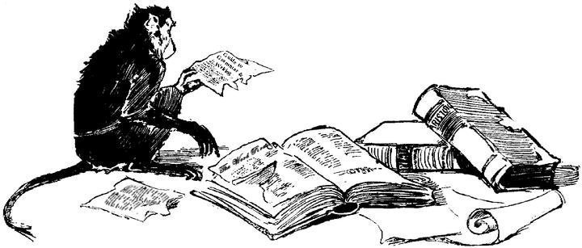
AP Exam Review

- Earth Systems and Resources (10–15%)
  - Earth Science Concepts (Geologic time scale; plate tectonics, earthquakes, volcanism; seasons; solar intensity and latitude)
  - The Atmosphere (Composition; structure; weather and climate; atmospheric circulation and the Coriolis Effect; atmosphere–ocean interactions; ENSO)
  - Global Water Resources and Use (Freshwater/saltwater; ocean circulation; agricultural, industrial, and domestic use; surface and groundwater issues; global problems; conservation)
  - Soil and Soil Dynamics (Rock cycle; formation; composition; physical and chemical properties; main soil types; erosion and other soil problems; soil conservation)

- What are the three types of plate boundaries? Describe what happens at each.
- What causes the seasons?
- How does solar intensity change with latitude?
- Describe the layers of the atmosphere.
- What is the Coriolis effect? How does it affect atmospheric and oceanic circulation?
- What is ENSO? What are its effects?
- What is the number one use of freshwater resources?
- What are some of the negative effects of surface water diversions? Give an example of a NAMED diversion project.
- Describe the following soil properties: porosity, permeability, texture, nutrients, pH
- Describe the soil horizons.

- The Living World (10–15%)
  - Ecosystem Structure (Biological populations and communities; ecological niches; interactions among species; keystone species; species diversity and edge effects; major terrestrial and aquatic biomes)
  - Energy Flow (Photosynthesis and cellular respiration; food webs and trophic levels; ecological pyramids)
  - Ecosystem Diversity (Biodiversity; natural selection; evolution; ecosystem services)
  - Natural Ecosystem Change (Climate shifts; species movement; ecological succession)
  - Natural Biogeochemical Cycles (Carbon, nitrogen, phosphorus, sulfur, water, conservation of matter)

- Define niche.
- Describe the types of symbiotic relationships and give an example of each.
- What is a keystone species?
- Describe the temperature, precipitation, flora and fauna of the following biomes:
  - Tropical Rainforest, Deciduous Forest, Coniferous Forest (Taiga)
  - Tropical Grassland (Savanna), Temperate Grassland (Prairie), Tundra
  - Desert
- Describe the energy flow in a food web.
- What are the inputs and outputs of photosynthesis and respiration?
- What is natural selection?
- How is evolution/diversity affected by island biogeography?
- Describe the two types of ecological succession
- What are the major carbon sinks?
- How are humans affecting the carbon cycle? Nitrogen cycle? Phosphorus cycle? Sulfur cycle?

- Population (10–15%)
  - Population Biology Concepts (Population ecology; carrying capacity; reproductive strategies; survivorship)
  - Human Population
    - Human population dynamics (Historical population sizes; distribution; fertility rates; growth rates and doubling times; demographic transition; age-structure diagrams)
    - Population size (Strategies for sustainability; case studies; national policies)
    - Impacts of population growth (Hunger; disease; economic effects; resource use; habitat destruction)

- What is carrying capacity?
- What is the difference between a R- and K- strategist? Give an example of each.
- Draw a survivorship curve for each of the following: early loss, late loss, constant loss. Be sure to label the axes!
- How has human population change over time?
- How do you calculate annual growth rate? Population change? Doubling time?
- Draw a simple age-structure diagram for a developed and a developing country.
- Describe the following graph: What does each line represent? What does each stage represent?
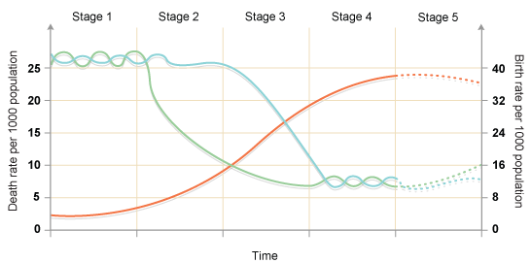

- Land and Water Use (10–15%)
  - Agriculture
    - Feeding a growing population (Human nutritional requirements; types of agriculture; Green Revolution; genetic engineering and crop production; deforestation; irrigation; sustainable agriculture)
    - Controlling pests (Types of pesticides; costs and benefits of pesticide use; integrated pest management; relevant laws)
  - Forestry (Tree plantations; old growth forests; forest fires; forest management; national forests)
  - Rangelands (Overgrazing; deforestation; desertification; rangeland management; federal rangelands)
  - Other Land Use
    - Urban land development (Planned development; suburban sprawl; urbanization)
    - Transportation infrastructure (Federal highway system; canals and channels; roadless areas; ecosystem impacts)
    - Public and federal lands (Management; wilderness areas; national parks; wildlife refuges; forests; wetlands)
    - Land conservation options (Preservation; remediation; mitigation; restoration)
    - Sustainable land-use strategies
  - Mining (Mineral formation; extraction; global reserves; relevant laws and treaties)
  - Fishing (Fishing techniques; overfishing; aquaculture; relevant laws and treaties)
  - Global Economics (Globalization; World Bank; Tragedy of the Commons; relevant laws and treaties)

- Why is industrial monoculture high input?
- What is the Green Revolution?
- What are GMOs?
- What are the issues with irrigation? Which type is the most efficient?
- Give examples of practices in sustainable agriculture.
- What is integrated pest management?
- What are the relevant laws of pesticide use in the U.S.?
- What is urban sprawl? Smartgrowth?
- What is mitigation? Give an example.
- Describe the following: strip mining, contour mining, mountain top removal, subsurface mining
- Where are the most abundant global reserves of the following: coal, oil, natural gas
- What are the relevant laws dealing with mining and reclamation?
- What is reclamation?
- What is globalization?
- What is tragedy of the commons?

- Energy Resources and Consumption (10–15%)
  - Energy Concepts (Energy forms; power; units; conversions; Laws of Thermodynamics)
  - Energy Consumption
    - History (Industrial Revolution; exponential growth; energy crisis)
    - Present global energy use
    - Future energy needs
  - Fossil Fuel Resources and Use (Formation of coal, oil, and natural gas; extraction/purification methods; world reserves and global demand; synfuels; environmental advantages/ disadvantages of sources)
  - Nuclear Energy (Nuclear fission process; nuclear fuel; electricity production; nuclear reactor types; environmental advantages/disadvantages; safety issues; radiation and human health; radioactive wastes; nuclear fusion)
  - Hydroelectric Power (Dams; flood control; salmon; silting; other impacts)
  - Energy Conservation (Energy efficiency; CAFE standards; hybrid electric vehicles; mass transit)
  - Renewable Energy (Solar energy; solar electricity; hydrogen fuel cells; biomass; wind energy; small-scale hydroelectric; ocean waves and tidal energy; geothermal; environmental advantages/disadvantages)

- Describe the 1st and 2nd laws of thermodynamics
- Describe the stages of coal formation
- How is oil extracted?
- Describe fracking.
- Describe the nuclear fission process. How is it used to produce electricity? How do we deal with the wastes?
- What are the advantages and disadvantages to hydroelectric power?
- What are the advantages and disadvantages of the following power sources: solar, hydrogen fuel cells, biomass, wind, waves and tides, geothermal
- What is the difference between active and passive solar energy

- Pollution (25–30%)
  - Pollution Types
    - Air pollution (Sources—primary and secondary; major air pollutants; measurement units; smog; acid deposition—causes and effects; heat islands and temperature inversions; indoor air pollution; remediation and reduction strategies; Clean Air Act and other relevant laws)
    - Noise pollution (Sources; effects; control measures)
    - Water pollution (Types; sources, causes, and effects; cultural eutrophication; groundwater pollution; maintaining water quality; water purification; sewage treatment/septic systems; Clean Water Act and other relevant laws)
    - Solid waste (Types; disposal; reduction)
  - Impacts on the Environment and Human Health
    - Hazards to human health (Environmental risk analysis; acute and chronic effects; dose-response relationships; air pollutants; smoking and other risks)
    - Hazardous chemicals in the environment (Types of hazardous waste; treatment/disposal of hazardous waste; cleanup of contaminated sites; biomagnification; relevant laws)
  - Economic Impacts (Cost-benefit analysis; externalities; marginal costs; sustainability)

- What is the difference between primary and secondary air pollutants? Give an example of each.
- List the 6 criteria air pollutants (NAAQS). What is the source and effect of each.
- Describe the formation of photochemical smog.
- What is acid deposition? What are the causes? Effects?
- What is the heat island effect?
- What is a temperature inversion? How does it affect air pollution?
- What are the most dangerous indoor air pollutants in a developed country? Developing country?
- What is sick building syndrome?
- Describe the Clean Air Act
- What are the sources of water pollution.
- What are the effects of organic pollutants? (relate to DO and BOD)
- What is cultural eutrophication? Causes? Effects?
- Describe water treatment and waste water treatment processes.
- What and how does each of the following target in waste water treatment: primary, secondary, advanced treatment
- Describe the Clean Water and Safe Drinking Water Acts
- How do we dispose of solid waste? What are the advantages and disadvantages to each?
- How do we dispose of hazardous waste?
- Describe CERCLA(Superfund) and RCRA
- What is LD50?
- What is bioaccumulation? Biomagnifications? Give an example.

- Global Change (10–15%)
  - Stratospheric Ozone (Formation of stratospheric ozone; ultraviolet radiation; causes of ozone depletion; effects of ozone depletion; strategies for reducing ozone depletion; relevant laws and treaties)
  - Global Warming (Greenhouse gases and the greenhouse effect; impacts and consequences of global warming; reducing climate change; relevant laws and treaties)
  - Loss of Biodiversity
    - Habitat loss; overuse; pollution; introduced species; endangered and extinct species
    - Maintenance through conservation
    - Relevant laws and treaties

- How does stratospheric ozone form?
- What are the causes/sources of ozone depletion? Describe the process.
- Describe the Montreal Protocol.
- What is the greenhouse effect? What are the major greenhouse gases?
- What are some impacts of global warming?
- Describe the Kyoto Protocol
- What are the major causes of habitat loss?
- What is a nonnative/alien/introduced species? Give an example and describe its effects.
- How can we conserve our endangered species? What is the best approach? What are the relevant laws and treaties?

